

**Polling District and Polling Place Review 2025**

**Walker Ward**

**Parliamentary Constituency:** East and Wallsend

**(Proposed) Polling Districts:** W01, W02, W03, W04, W05

The Local Government Boundary Commission for England are an independent body accountable to Parliament. They are responsible for reviewing councils to make sure their patterns of internal wards are fair and sensible. Their reviews include at least two rounds of public consultation before they make recommendations for change.

The final recommendations were published on 7 January 2025, and the new arrangements apply to local elections from 2026.

As a result of changes to ward boundaries the Acting Returning Officer (ARO) is conducting a review of polling districts and polling places to ensure that they are suitable for the new ward boundaries.

For more information on the local government boundary review visit: <https://www.lgbce.org.uk/all-reviews/newcastle-upon-tyne>

This document provides details of the review, along with the initial recommendations and comments of the Acting Returning Officer (ARO). Also, the election rules require the ARO to decide how many polling stations are required for each polling station and the ARO must allocate electors to the polling stations in such manner as they think most convenient.

These recommendations will be open to all residents, stakeholders, and any interested parties. We shall be seeking representations from local disability groups on the accessibility and suitability of polling places. Any comments should be addressed in the first instance to pollingplaces@newcastle.gov.uk where they will be collated on behalf of the (Acting) Returning Officer.

We considered the following factors:

* **Identifying new polling places:** We will look for new polling places in areas where the existing provision is unsuitable or unavailable.
* **Feedback:** We will consider feedback received following recent elections, consultation from members of the public, elected members, and other stakeholders.
* **Accessibility:** We will try to ensure that every polling place is accessible to electors with disabilities.
* **Facilities**: We will make sure that all electors have such reasonable facilities for voting as are practicable in the circumstances.
* **Elector numbers:** We will try to comply with the Electoral Commission guidance on the maximum number of electors that should be allocated to a polling station which should not exceed 2,250.
* **Future housing developments**: We will consider the impact of proposed housing developments on polling station electorates.

**(Current) Walker Ward**

This map shows the current ward and polling district boundaries and the polling places.

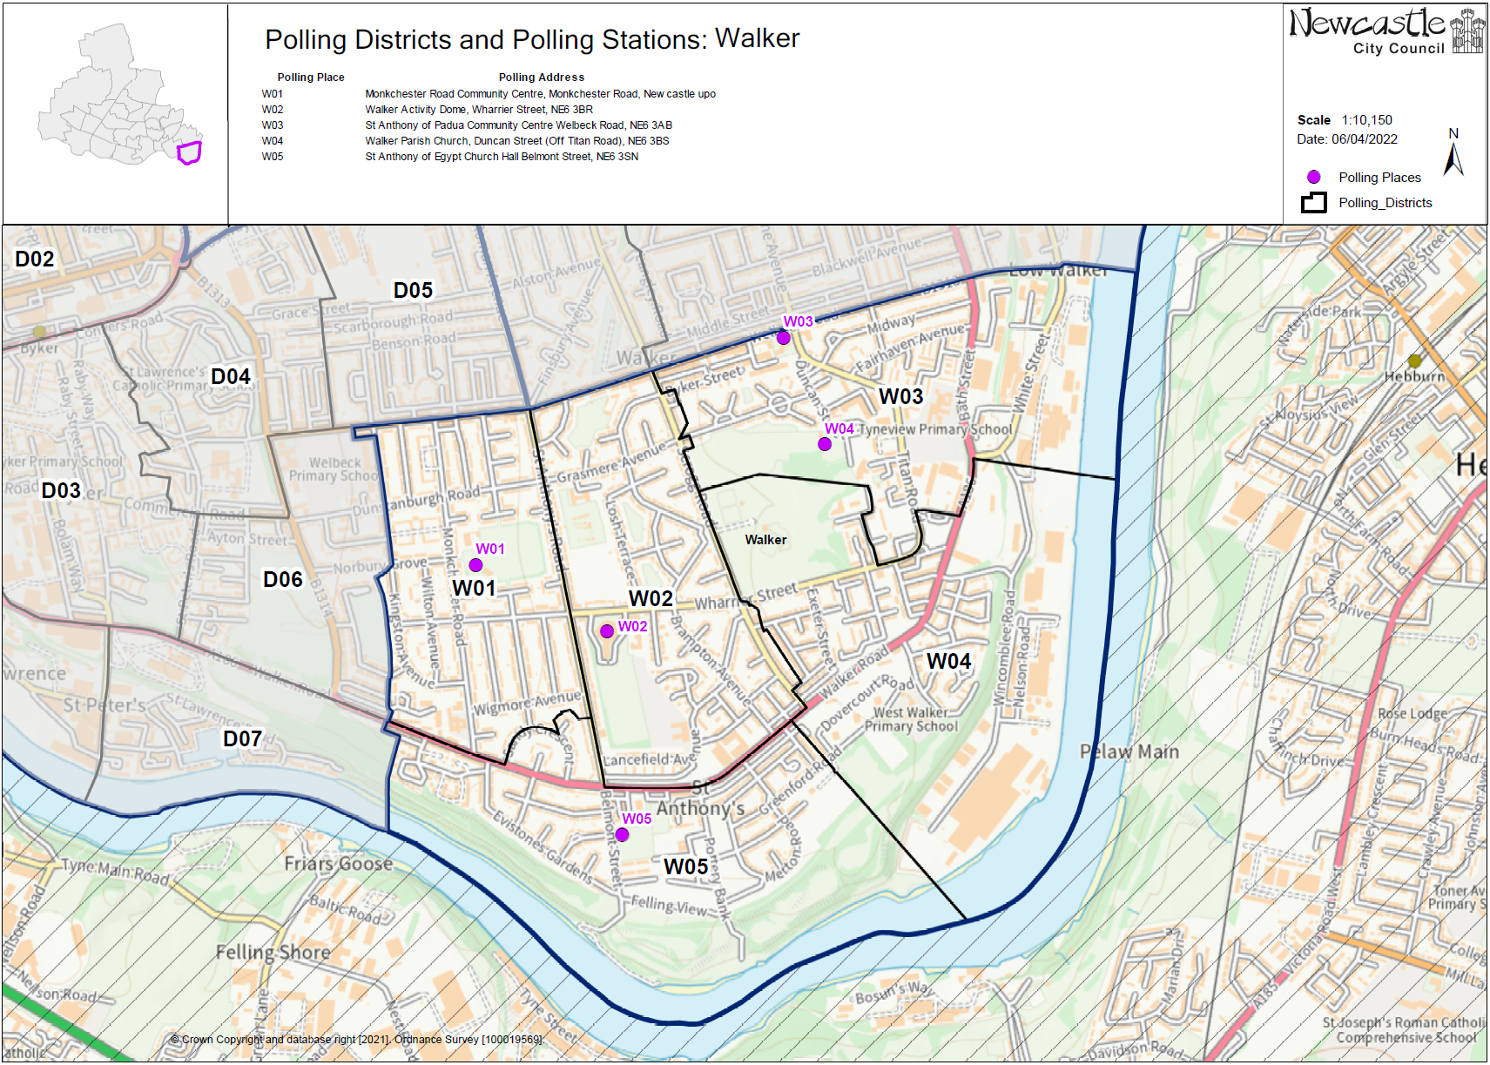

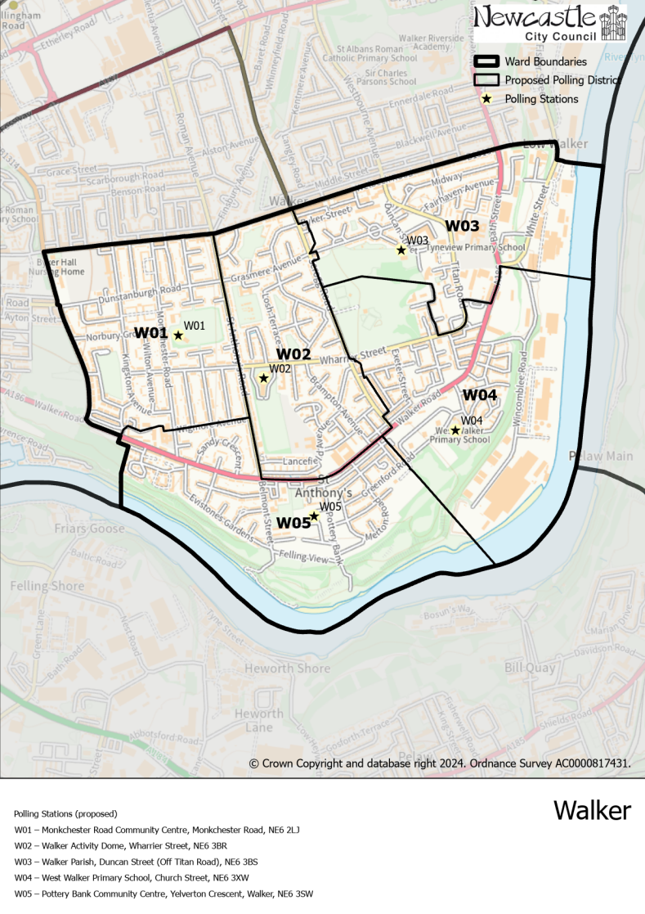**(New)**

**Walker Ward**

This map shows the new ward and the proposed polling districts and the proposed polling places.

* **W01**

Monkchester Road Community Centre, Monkchester Road, NE6 2LJ

* **W02**

Walker Activity Dome, Wharrier Street, NE6 3BR

* **W03**

Walker Parish, Duncan Street (Off Titan Road), NE6 3BS

* **W04**

West Walker Primary School, Church Street, NE6 3XW

* **W05**

Pottery Bank Community Centre, Yelverton Crescent, Walker, NE6 3SW

**Walker Ward**

**Polling District W01**

|  |  |
| --- | --- |
| **Current Polling District** | **Current Polling Place** |
| D06 (part of)  W01 (full) | Welbeck Road Evangelical Church, Welbeck Road, Byker, NE6 2HU  Monkchester Road Community Centre, Monkchester Road, NE6 2LJ |

|  |  |  |
| --- | --- | --- |
| **Proposed Polling District** | **Predicted**  **Polling Station Electorate** | **Proposed Polling Place** |
| W01 | 1452 | Monkchester Road Community Centre, Monkchester Road, NE6 2LJ |

|  |
| --- |
| **Considerations and Proposals** |
| Part of the current D06 would merge with the current W01 to form the proposed W01 district.  The district would also lose a small area to W05. Properties west to Allendale Road, would form the proposed W01 district. Losing a small part of the district, south of Wigmore Avenue, to the proposed W05 district.  Monkchester Road Community Centre is the suggested polling station for this district. |

|  |
| --- |
| **Preliminary Consultation – Elected Members comments and feedback** |
| No comments received. |

**Walker Ward**

**Polling District W02**

|  |  |
| --- | --- |
| **Current Polling District** | **Current Polling Place** |
| W02 (full) | Walker Activity Dome, Wharrier Street, NE6 3BR |

|  |  |  |
| --- | --- | --- |
| **Proposed Polling District** | **Predicted**  **Polling Station Electorate** | **Proposed Polling Place** |
| W02 | 1162 | Walker Activity Dome, Wharrier Street, NE6 3BR |

|  |
| --- |
| **Considerations and Proposals** |
| No changes to the polling district boundary.  No change to the polling place. |

|  |
| --- |
| **Preliminary Consultation – Elected Members comments and feedback** |
| No comments received. |

**Walker Ward**

**Polling District W03**

|  |  |
| --- | --- |
| **Current Polling District** | **Current Polling Place** |
| W03 (full) | St Anthony of Padua Community Centre, Welbeck Road, NE6 3AB |

|  |  |  |
| --- | --- | --- |
| **Proposed Polling District** | **Predicted**  **Polling Station Electorate** | **Proposed Polling Place** |
| W03 | 752 | Walker Parish, Duncan Street (Off Titan Road), NE6 3BS |

|  |
| --- |
| **Considerations and Proposals** |
| This district loses a small non-residential area to Walkergate ward.  Loses part of unnamed road at the bottom of Welbeck Road, just off White Street.  Walker Parish is more centrally located within the new polling district; however, St Anthony of Padua is still within the district so is also a potential option. |

|  |
| --- |
| **Preliminary Consultation – Elected Members comments and feedback** |
| No comments received. |

**Walker Ward**

**Polling District W04**

|  |  |
| --- | --- |
| **Current Polling District** | **Current Polling Place** |
| W04 (full) | Walker Parish, Duncan Street (Off Titan Road), NE6 3BS |

|  |  |  |
| --- | --- | --- |
| **Proposed Polling District** | **Predicted**  **Polling Station Electorate** | **Proposed Polling Place** |
| W04 | 742 | West Walker Primary School, Church Street, NE6 3XW |

|  |
| --- |
| **Considerations and Proposals** |
| No changes to the polling district boundary.  West Walker Primary School is the suggestion for this district. A site visit has been conducted and accessibility guidelines have been met. |

|  |
| --- |
| **Preliminary Consultation – Elected Members comments and feedback** |
| No comments received. |

**Walker Ward**

**Polling District W05**

|  |  |
| --- | --- |
| **Current Polling District** | **Current Polling Place** |
| W05 (full) | St Anthony of Egypt Church Hall, Belmont Street, NE6 3SN |

|  |  |  |
| --- | --- | --- |
| **Proposed Polling District** | **Predicted**  **Polling Station Electorate** | **Proposed Polling Place** |
| W05 | 1085 | Pottery Bank Community Centre, Yelverton Crescent, Walker, NE6 3SW |

|  |
| --- |
| **Considerations and Proposals** |
| Gains part of the current W01 district. Properties south of Wigmore Avenue, including Sandy Crescent would become part of the proposed W05.  Pottery Bank Community Centre is the suggested polling station for this district; however, St Anthony of Egypt Church Hall is still within the district so is also a possibility. |

|  |
| --- |
| **Preliminary Consultation – Elected Members comments and feedback** |
| No comments received. |